

About Get Covered America and Enroll America
Get Covered America is a national campaign of Enroll America that is focused on educating consumers about the benefits of health coverage and the new health insurance available under the Affordable Care Act. With operations in eleven states (AZ, FL,GA, IL, MI, NC, NJ, OH, PA,TN and TX), our grassroots team is powered by passionate staff and volunteers with one motivating goal: to give Americans the information they need to choose an affordable health insurance plan that’s right for them and their families. Enroll America is the nation’s leading health care enrollment coalition, bringing together community and health organizations, businesses and others to inform consumers about the new health coverage options and how to enroll in them. It is an independent, nonpartisan, nonprofit 501c(3) organization.

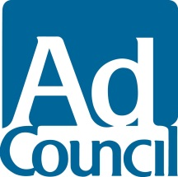
About The Ad Council
The Ad Council is a private, non-profit organization with a rich history of marshalling volunteer talent from the advertising and media industries to deliver critical messages to the American public. Having produced literally thousands of PSA campaigns addressing the most pressing social issues of the day, the Ad Council has affected, and continues to affect, tremendous positive change by raising awareness, inspiring action and saving lives. To learn more about the Ad Council and its campaigns, visit www.adcouncil.org, like us on Facebook, follow us on Twitter or view our PSAs on YouTube.



About La Comunidad
La Comunidad believes in the power of connecting people and ideas. The concept of community empowers people and inspires collaboration. Founded in 2001, La Comunidad is a global agency known for innovative cross-cultural communications for multinational brands.
Featured on the Advertising Age ‘Agency to watch’ list in 2012 and ‘A-List’ in 2013, the agency has been ranked as the 13th most awarded agency in the world (Gunn Report). It was also named by Adweek’s “Multicultural Agency of the Year” in 2006.
The company is headquartered in Miami, and has three offices—two in Miami and one in Buenos Aires. La Comunidad’s iconic client roster includes Time Warner Cable, Sauza and Hornitos Tequilas, Apple, Converse, Corona Extra, Modelo Especial, Diageo, MTV Networks, Rolling Stone and Kraft among others. Learn more at www.lacomunidad.com, join us at Facebook.com/TheCommunitarians or follow us on Twitter @Communitarians.


About Razorfish
Obsessed, motivated and inspired by what's next, Razorfish helps its clients navigate the unknown, drive change and enable business transformation. One of the first pioneers of marketing in the digital age, Razorfish has technology, creativity and media at its core. Our world class capabilities in strategic consulting, experience design, brand building, technology platforms, data services, retail/commerce and media services enable us to deliver transformational work for clients including Delta, McDonald’s, Mercedes, Microsoft, Nike, Unilever and Uniqlo. Our team of 3000 experts is located in 19 regions including Australia, Brazil, China, Germany, Hong Kong, India, Japan, Singapore, the United Kingdom and the United States.
Razorfish is part of Publicis Groupe. For more information visit Razorfish.com, like us on Facebook or follow us on Twitter. Razorfish. Here for tomorrow.

About Mindshare
Mindshare is a global media agency network with billings in excess of US$29.2 billion (source: RECMA). The network consists of 113 offices in 82 countries throughout North America, Latin America, Europe, Middle East, and Asia Pacific, each dedicated to forging competitive marketing advantage for businesses and their brands. Mindshare is part of GroupM, which oversees the media investment management sector for WPP, the world’s leading communications services group.

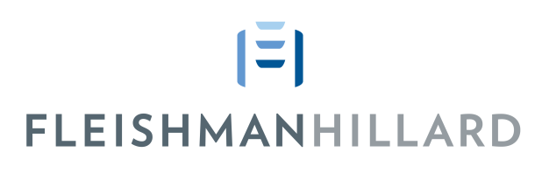
About Fleishman Hillard
FleishmanHillard is the world’s most complete global communications firm, specializing in public relations, public affairs, marketing, paid media, and transmedia and social content. FleishmanHillard delivers on The Power of True, reflecting the firm’s high values, and unique ability to guide clients through a world demanding unprecedented authenticity and transparency. FleishmanHillard was named “Standout Agency” on Advertising Age’s 2013 A-List; NAFE’s “Top 50 Companies for Executive Women” for 2010-2013; Advertising Age’s 2012 “Best Places to Work”; and The Holmes Report’s 2012 Global “Public Affairs Agency of the Year.” The firm’s award-winning work is widely heralded, including at the Cannes International Festival of Creativity. FleishmanHillard is part of Diversified Agency Services, a division of Omnicom Group Inc., and has more than 85 offices in 30 countries, plus affiliates in 42 countries. Visit us at www.fleishmanhillard.com.

